My Rewardz
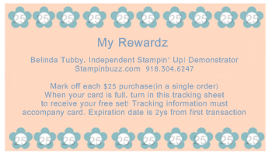
Last Name: ______________________________________________________________________________________

City/St/Zip: _____________________________________________________________________________

Phone: _______________________________________________________________________________________________

First Name: _____________________________________________________________________________________

Street: _______________________________________________________________________________________________

Email: _________________________________________________________________________________________________

Date of Purchase | Online Order # or  Hostess Code # | Order Total  (before tax and shipping) | Rewardz points earned  (1 for each $25)
Please read full promotion rules below to determine which purchases and amounts qualify for Rewardz points!
Date of Purchase | Online Order # or  Hostess Code # | Order Total  (before tax and shipping) | Rewardz points earned  (1 for each $25)
Points expire 2 yrs from purchase date. All terms and conditions of this offer are subject to change at any time.
Free Set Name: Item number:

Promotion Details
- Earn 1 Rewardz point for each $25.00 that you spend in a single order on current product. Tax and Shipping do not count towards your point total. Place your order by phone (918.304.6247), email or in my online store.
- Only full $25 increments (before tax and shipping) in a single order, earn points. Additional amounts do not carry over. If you place an order that is $49.00 before tax and shipping, you will earn 1 Rewardz point. $50.00-$74.99 earns 2 points, $75.00-$99.99 earns 3 points, etc. Points expire 2 years from purchase date.
- Only current Stampin’ Up! product ordered through me, qualifies for Rewardz points. Stampin’ Up! sponsored, specially priced, bundled and clearance rack items Do qualify as priced, not at full value.
- Hostess benefits and half price items do not earn points. Individual orders that qualify for hostess benefits do earn points.
- Specials that are offered by me and not Stampin’ Up! do not earn Rewardz points.
- Club minimums do not earn Rewardz points. However, amounts that total full $25 increments over the club minimum, do earn Rewardz points.
- Retired product, kits, tutorials, premade items or any other specialty items sold by me personally, do not earn Rewardz points.
- Class, Stamp Camp, Stamp a Stack, Stampfest or any other event fees, do not earn Rewardz points.
- You must track your own purchases and then send this completed form to me to redeem your free set. I need a date and order number, hostess code or hostess name to verify your order.
- Free sets will be verified and mailed out or delivered, please allow 2-3 weeks for this process to complete.

